MARRIAGE PREPARATION
All couples are asked to participate in a Marriage Preparation program. A variety of dates and locations is available by visiting one of the following websites:
www.fallriverfaithformation.org/marriage-prep.html
www.bostoncatholic.org/familylife/transformedinlove
Due to COVID restrictions, you can also choose to complete the course online at:
https://www.mycatholicfaithdelivered.com/home.aspx?pagename=togetherinGodslove
Once complete, you will receive a certificate that should be given to the priest or deacon preparing your wedding.

PERSONALIZE YOUR WEDDING
You will receive the booklet, Together for Life, which contains readings and prayer options that you can select to personalize your wedding and include family and friends in this special day. The priest or deacon will provide you with the booklet. The selection sheet should be sent to the parish office the week prior to the wedding.

REHEARSAL
The date and time of the rehearsal will be arranged when the wedding date is scheduled, usually at the initial meeting with the priest or deacon.
Everyone who will participate in the wedding should attend the rehearsal, e.g. readers, ushers, bridesmaids, etc. The wedding coordinator will direct the rehearsals and coordinates the procession the day of the wedding.

For the rehearsal:
- Please be on time;
- Give a copy of the reading to the readers;
- Provide a written list of the attendants in order of procession;
- Determine the order of procession you desire, e.g. bridesmaids, flower girl, etc.
- Decide who will seat the parents, etc.

OFFERING TO THE CHURCH
The customary donation for parishioners is $350 and it includes a stipend for the wedding coordinator and altar server. The other fees for music and flowers are arranged separately by the couple.

SACRAMENT OF RECONCILIATION
Couples should prepare to celebrate their new beginning together by going to confession, or Reconciliation, prior to the rehearsal. The Sacrament of Reconciliation will allow you to review your past as a single person and begin your married life with God’s grace. Please consult the parish bulletin for the Confession schedule or make an appointment with the priest. You may consider a visit to LaSalette Shrine for Confession, as well.
f
Check list:
- Meet with priest or deacon to set wedding date & reserve the church
- Contact musician(s) to reserve date
- Complete FOCCUS Inventory online
- Register for Marriage Preparation Class
- Send Baptism & Confirmation certificates to parish office
- Schedule Wedding Rehearsal
- Complete Wedding selection sheet
- Apply for Marriage License
- Send License to the parish office

The Parish of
St. John the Evangelist
welcomes you

Celebration of the
Sacrament of Marriage

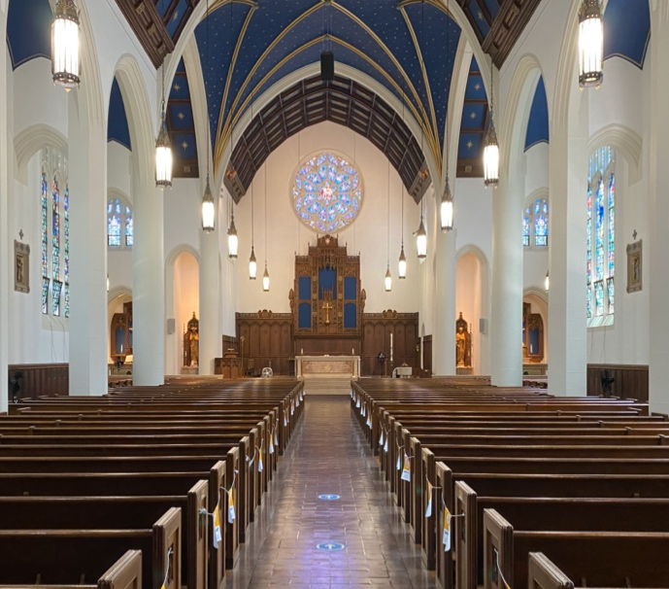

Parish Office
1 Saint John’s Place
Attleboro, Massachusetts 02703

Church
133 North Main Street
Attleboro, MA 02703

Phone: (508) 222-1206
Fax: (508) 226-6461
Email: Office@attleborocatholics.org Website: www.AttleboroCatholics.org
To the engaged couples: Congratulations on your plans to celebrate the Sacrament of Marriage here at St. John the Evangelist Church! We hope the following information will help you in the process of preparing for the special day.
Once you have made the decision to marry, the process generally begins with a call to the parish office to arrange an appointment to talk to the priest or deacon. You will set a date for the wedding and begin to complete the documentation needed. You will complete a compatibility inventory called FOCCUS, which is designed to prepare you for attending Marriage Preparation. In the meantime, you will gather certificates and meet with the priest or deacon as needed to complete the paperwork. Once done, you will attend the rehearsal, celebrate the wedding and be off on your honeymoon!
Feel free to call the parish office anytime if you have questions about your wedding. We are here to help!

WEDDING DAY & TIME
Most weddings are celebrated on Saturdays (until 1:30PM or after 5:30PM) or Sundays (after 1:00 PM until 3:00 PM). Other days are possible, as well. The priest or deacon preparing your wedding can help selecting the date and time for your wedding here.

WEDDING COORDINATOR
Mary Robinson serves as the parish Wedding Coordinator and will direct the rehearsal and the wedding day. If you have any questions, please contact Mary: Marobinson7@icloud.com
MUSIC
You should contact Sheryl Walsh, parish Director of Music, at (508) 222-6383 as soon as you set your date. Sheryl will make arrangements to meet with you to discuss and plan your wedding music, including the possibility of other musicians or soloists.

SACRAMENTAL CERTIFICATES
Catholics are asked to provide a recent (within 6 months) original certificate of Baptism and Confirmation. Baptized Christians are asked to provide a copy of their Baptism certificate.

FLOWERS & DECORATIONS
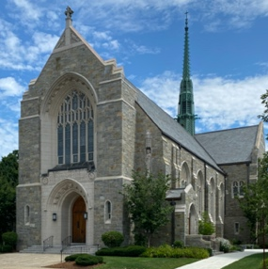
If you are selecting flowers to decorate the church, ask the florist to contact the parish office to schedule delivery time. You may decorate the pews with bows, flowers, etc., however kindly use clips, not tape, to hold them in place so as to not damage the wood finish on the benches.
Traditionally, some wedding flowers remain in the church, with the exception of pew decorations. Kindly have someone remove the pew bows, programs, etc., after the wedding.
Since the floor is stone, a white aisle runner should not be used. For cleanliness and safety please do not throw rice, bird seed, flower petals, confetti, etc., inside or outside the church. Dogs, cats, doves, etc., should not be included in the church part of the wedding day.

PHOTOGRAPHY & VIDEOTAPING
Your photographer and/or videographer is welcome throughout the ceremony without interrupting the natural flow of the wedding. They may photograph from the choir loft or any part of the nave of the church while not entering the Sanctuary section (past the altar rail). The church and grounds are available for 30 minutes following the wedding for photographs. Any questions can be directed to the Wedding Coordinator, or call the parish office.

MARRIAGE LICENSE
The couple is required to provide a Marriage License prior to the wedding. You are both required to apply in person to the City Clerk’s Office in ANY town or city hall in the Commonwealth of Massachusetts. The license is valid for sixty days. Please note: there is a 3-day waiting period before the license can be issued.
Once obtained, the license should be brought to the parish office before the rehearsal. A wedding cannot be held if there is no Marriage License. Following the wedding, the priest or deacon is responsible for completing it and returning it to the City Clerk’s office. After it is recorded there, you may contact the City Clerk for a certified copy. At the wedding you will receive a Marriage Certificate provided by the parish.

VISITING CLERGY
If you are inviting a priest or deacon, who lives out-of-state, to perform the wedding, he must apply for a “commission” from the MA Secretary of State. Division of Pubic Records (617) 727-2936.
In addition, any priest or deacon who is invited to participate in the wedding must provide a “Letter of Suitability” from the Diocese in which he serves. The letter must be sent to the parish office one month prior to the date of the wedding so it can be processed.

